**College Scorecard Data Visualization**

* Roshan

**Current Search results page for schools in North Carolina:**

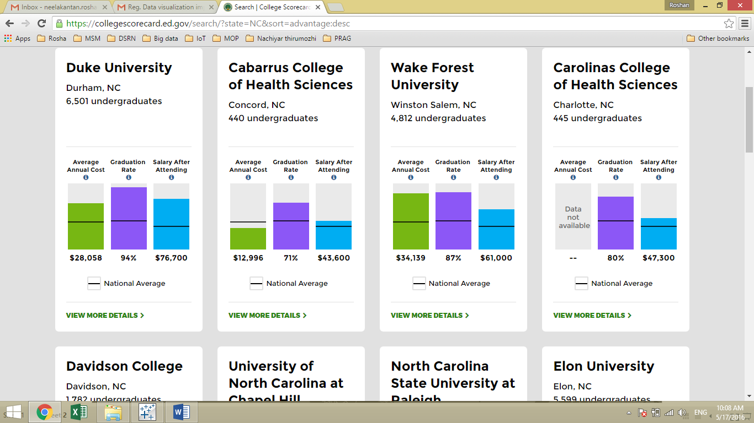

This pages shows information about,

1. Institution name
2. City & State
3. Number of undergraduate degree seeking students
4. Average annual cost
5. Graduation Rate
6. Salary after attending
7. National average

**Proposed visualization for North Carolina:**

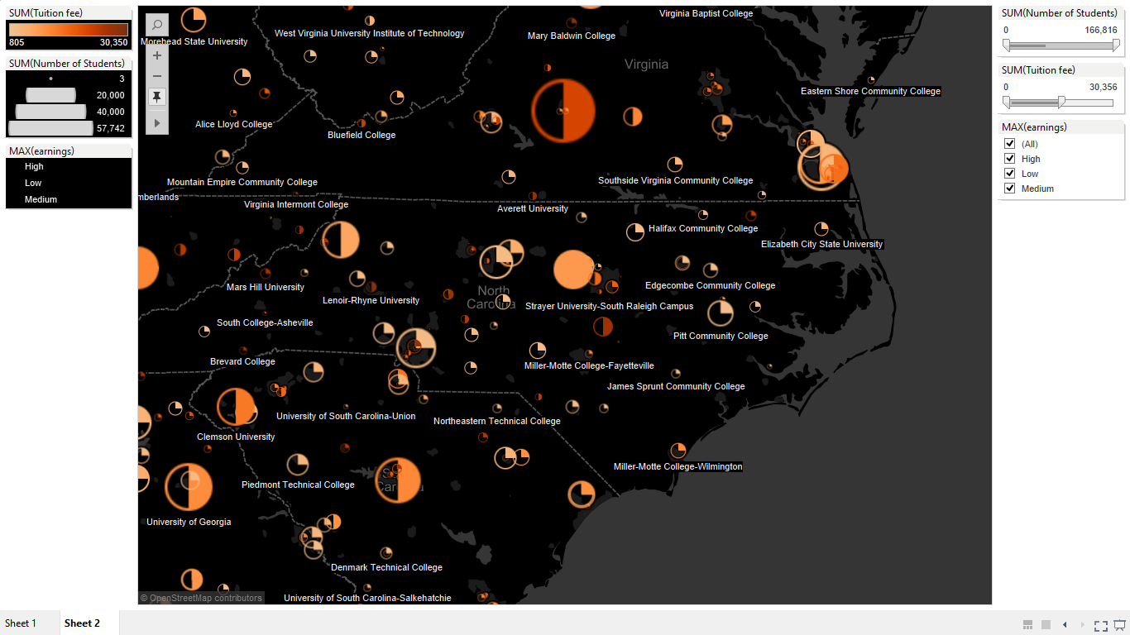

**For Example – University of North Carolina Chapel Hill**

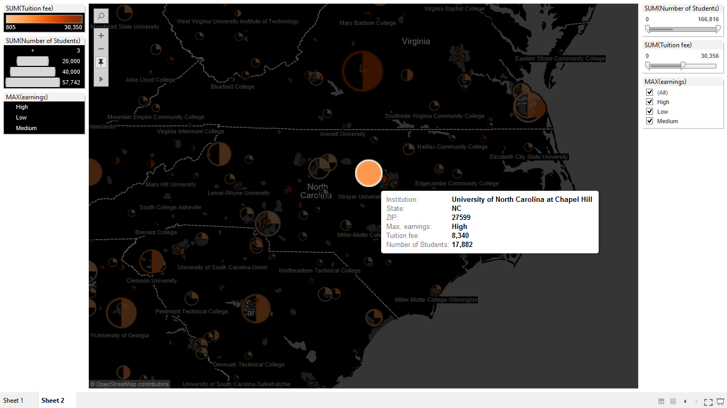

**Shape of the circle:**

|  |  |
| --- | --- |
| **Proportion** | **Mean Earnings** |
| **C:\Users\Roshan\Documents\My Tableau Repository\Shapes\Proportions\1.png** | If mean earnings is less than $40,000 |
| **C:\Users\Roshan\Documents\My Tableau Repository\Shapes\Proportions\2.png** | If mean earnings is between $40,000 and $60,000 |
| **C:\Users\Roshan\Documents\My Tableau Repository\Shapes\Proportions\4.png** | If mean earnings is greater than $60,000 |

**Size of the circle** depends on the numbers of undergraduate degree seeking students. Smaller the circle, lesser is the number of students in that institution and vice versa.

**Color of the circle** depends on the average annual cost of that institution. The color intensifies to darker orange as this amount increases. For my project purpose, I have used the instate tuition fee variable in place of average annual cost.

Since I focussed on the best ROI (Earnings for tuition fee) colleges, I concentrated more on the above variables and did not include the graduation rate variable.

**Interactive filtering option:**

This visualization would allow the user to filter based on size (number of students); Tuition fee and mean earnings.

Let’s say I would want to see the colleges that has number of students below **5,381**; tuition fee less than **$15,701** and **medium** mean earnings

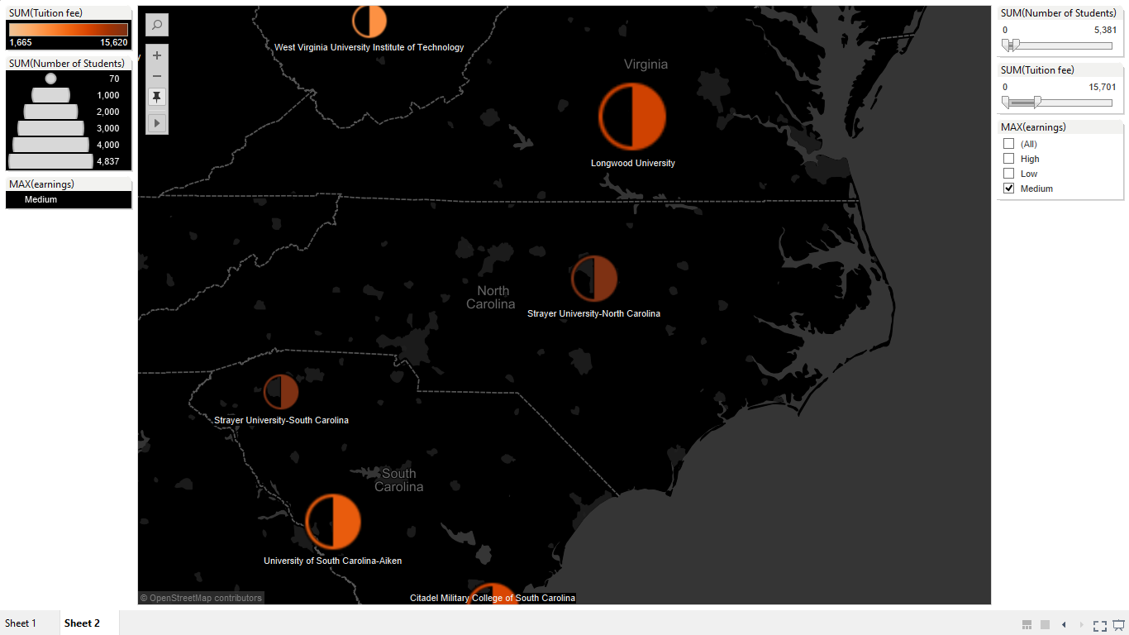

The only college that satisfies this condition in North Carolina is **Strayer University**. Although there are more colleges in **OHIO** if the user zooms to that state.

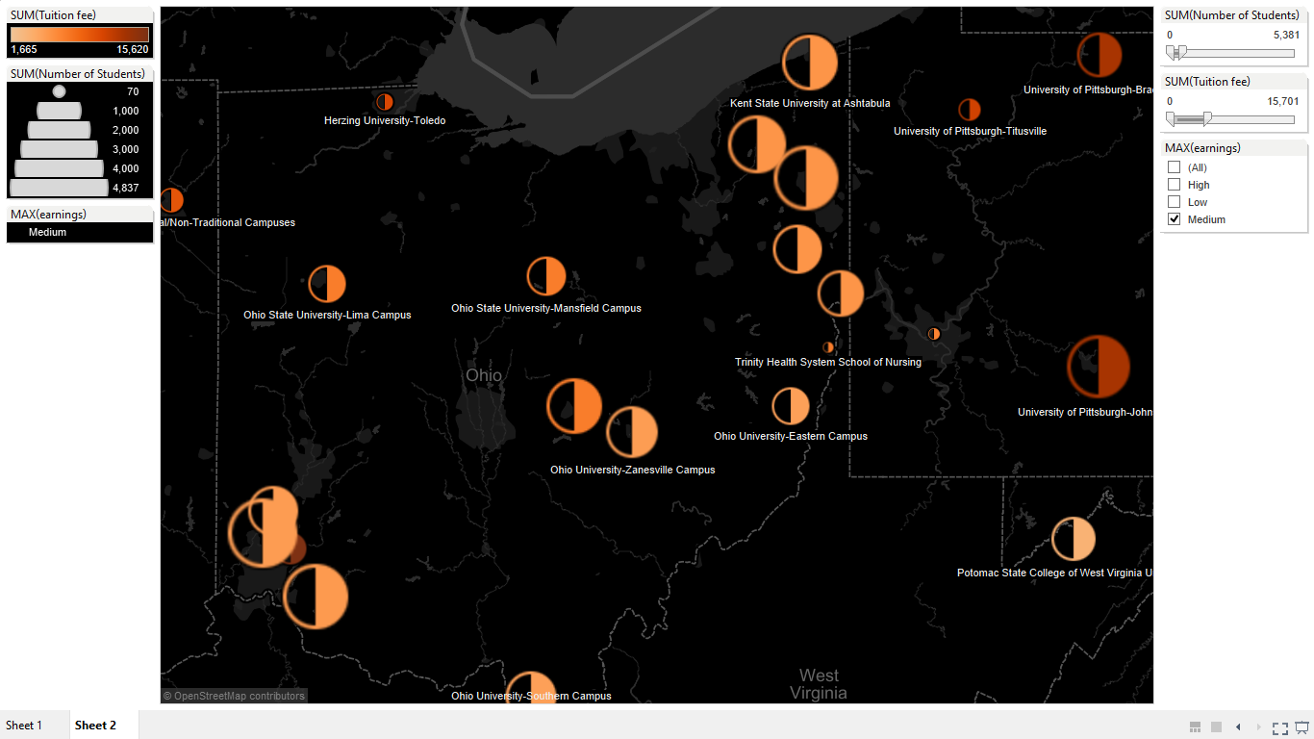

**Drawbacks:**

1. The webpage could take more time to load due to the map size and information
2. I have not included the national average for the various factors but my proposal would be to include a small text box underneath the map with these numbers.
3. Non-availability of graduation rate variable.
4. Colleges with the same zip-code can make the map look cramped.

**Future Scope:**

1. To include additional filters condition based on programs, degrees and type of school.
2. To use better shapes.

**Some more screen shots:**

